**TO START:**

1. Create a new database named "CompanyDB."
2. Create a schema named "Sales" within the "CompanyDB" database.
3. Create a table named "employees" with columns: employee_id (INT), first_name (VARCHAR), last_name (VARCHAR), and salary (DECIMAL) within the "Sales" schema.

Note: on employee_id use sequence instead of identity.

1. Alter the "employees" table to add a new column named "hire_date" with the data type DATE.
2. Add mock data to this table using <https://www.mockaroo.com>

**DATA MANIPULATION Exercises:**

1. Select all columns from the "employees" table.  
   
2. Retrieve only the "first_name" and "last_name" columns from the "employees" table.  
   
3. Retrieve “full name” as one column from the "first_name" and "last_name" columns from the "employees" table.  
   
4. Show the average salary of all employees.   
   
5. Select employees whose salary is greater than 50000.  
   
6. Retrieve employees hired in the year 2020.  
   
7. List employees whose last names start with 'S.'  
   
8. Display the top 10 highest-paid employees.  
   
9. Find employees with salaries between 40000 and 60000.  
   
10. Show employees with names containing the substring 'man.'  
    
11. Display employees with a NULL value in the "hire_date" column.  
    
12. Select employees with a salary in the set (40000, 45000, 50000).  
    
13. Retrieve employees hired between '2020-01-01' and '2021-01-01.'  
    
14. List employees with salaries in descending order.  
    
15. Show the first 5 employees ordered by "last_name" in ascending order.  
    
16. Display employees with a salary greater than 55000 and hired in 2020.  
    
17. Select employees whose first name is 'John' or 'Jane.'  
    
18. List employees with a salary less than or equal to 55000 and a hire date after '2022-01-01.'  
    
19. Retrieve employees with a salary greater than the average salary.  
    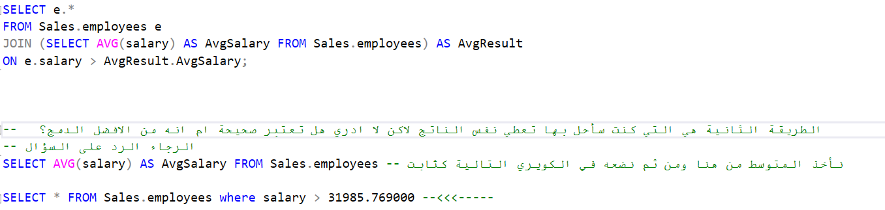
20. Display the 3rd to 7th highest-paid employees.  
    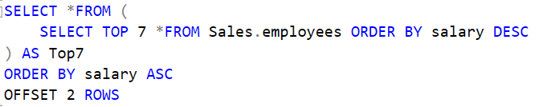
21. List employees hired after '2021-01-01' in alphabetical order.  
    
22. Retrieve employees with a salary greater than 50000 and last name not starting with 'A.'  
    
23. Display employees with a salary that is not NULL.  
    
24. Show employees with names containing 'e' or 'i' and a salary greater than 45000.  
    